Create capture

# Before starting with this document

Review ***Create token Instructions.doc***, that allows you have the following information needed to perform payments:

* Public-key
* Private-key
* app_id. (in this document we use **com.payu.colombia.testbusinessunit**)

Due to this document will be in test environment, the field **x-payments-os-env** will be “test”

Review ***Create payment.docx***, that allows you to have the following information to perform authorization:

* **id**. (the payment id)

# Perform capture

To perform a payment please refer to PayU-SETest/Perform capture.

Add parameters **app_id** and **public_key** according to ***Create token Instructions.doc***. You can use sample data in body or edit according to your test.

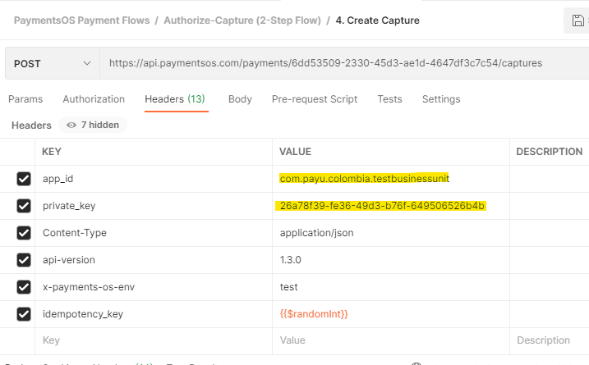

In request you can change url request and body with the information received when you create the payment and when you create the tokenized card.

* The payment id will be added to POST header.

Body have no content.



In response you will receive an id of your transaction, that you will use for refund, and capture.

{

    "id": "482ed15a-f542-4dd4-8777-d268842e697c",

    "created": "1614622052034",

    "result": {

        "status": "Succeed"

    },

    "amount": 4097,

    "provider_data": {

        "provider_name": "MockProcessor",

        "response_code": "0",

        "description": "Captured.",

        "raw_response": "{\"OID\":\"6dd53509-2330-45d3-ae1d-4647df3c7c54\",\"AUTH_CODE\":\"6dd53\",\"RETURN_MESSAGE\":\"Captured.\",\"TRANSID\":\"b1f06b32-2158-4ef9-b525-052b89a76055_250790b1-6f98-4fc6-95da-080562a7116a_Capture\",\"STATUS\":\"SUCCESS\",\"AMOUNT\":\"40.97\",\"DATE\":\"1614622052034\",\"RETURN_CODE\":\"0\",\"CURRENCY\":\"EUR\"}",

        "authorization_code": "6dd53",

        "transaction_id": "b1f06b32-2158-4ef9-b525-052b89a76055_250790b1-6f98-4fc6-95da-080562a7116a_Capture",

        "external_id": "6dd53509-2330-45d3-ae1d-4647df3c7c54"

    },

    "provider_configuration": {

        "id": "167c3475-1e82-4ee3-a16f-7077f0c5bb95",

        "name": "Mock provider",

        "description": "testing payu",

        "created": "1614605321141",

        "modified": "1614605321141",

        "account_id": "250790b1-6f98-4fc6-95da-080562a7116a",

        "provider_id": "c87ee096-e1a4-4502-9194-9e9b6e867bf0",

        "type": "cc_processor",

        "href": "https://api.paymentsos.com/accounts/250790b1-6f98-4fc6-95da-080562a7116a/provider-configurations/167c3475-1e82-4ee3-a16f-7077f0c5bb95"

    }

}